# 1

## Code

clc

clear all

close all

warning off

%For fs=1/(4*tau)

tau=10;

fs=1/(4*tau);

f=fs:fs:5;

G=tau*(sin(pi*f*tau)./(pi*f*tau));

figure(1)

subplot(2,1,1)

stem(G)

xlabel('k')

ylabel('G(f)')

title('freq domin at:fs=1/4tau')

g=ifft(G);

subplot(2,1,2)

stem(g)

xlabel('n')

ylabel('g(t)')

title('time domin at:fs=1/4tau')

%For fs=1/(2*tau)

tau=10;

fs=1/(2*tau);

f=fs:fs:5;

G=tau*(sin(pi*f*tau)./(pi*f*tau));

figure(2)

subplot(2,1,1)

stem(G)

xlabel('k')

ylabel('G(f)')

title('freq domin at:fs=1/2tau')

g=ifft(G);

subplot(2,1,2)

stem(g)

xlabel('n')

ylabel('g(t)')

title('time domin at:fs=1/2tau')

%For fs=1/(tau)

tau=10;

fs=1/(tau);

f=fs:fs:5;

G=tau*(sin(pi*f*tau)./(pi*f*tau));

figure(3)

subplot(2,1,1)

stem(G)

xlabel('k')

ylabel('G(f)')

title('freq domin at:fs=1/tau')

g=ifft(G);

subplot(2,1,2)

stem(g)

xlabel('n')

ylabel('g(t)')

title('time domin at:fs=1/tau')

## Output

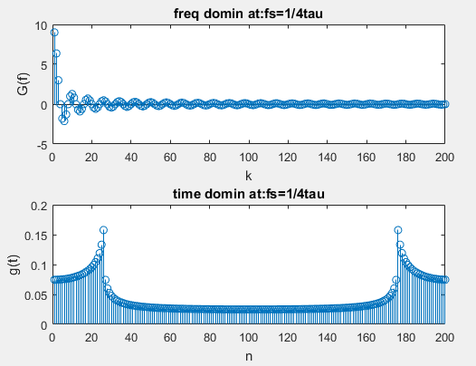

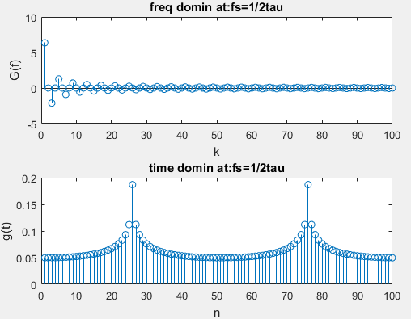

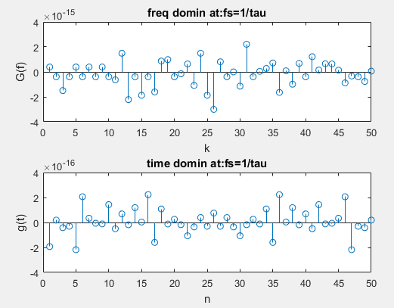

## Observation

As we the decrease the frequency same parodic width in time domain decrease.

# 2

## Code

clc

clear all

close all

warning off

%For Ts=tau

tau=10;

Ts=tau;

t=-tau/2:Ts:tau/2;

g=heaviside(t+tau/2)-heaviside(t-tau/2);

figure(1)

subplot(2,1,1)

stem(g)

xlabel('n')

ylabel('g(t)')

title('time domain at:Ts=tau')

G=fft(g);

subplot(2,1,2)

stem(G)

xlabel('k')

ylabel('G(f)')

title('frequency domain at:Ts=tau')

%For Ts=tau/2

tau=10;

Ts=tau/2;

t=-tau/2:Ts:tau/2;

g=heaviside(t+tau/2)-heaviside(t-tau/2);

figure(2)

subplot(2,1,1)

stem(g)

title('time domain at:Ts=tau/2')

xlabel('n')

ylabel('g(t)')

G=fft(g);

subplot(2,1,2)

stem(G)

xlabel('k')

ylabel('G(f)')

title('frequency domain at:Ts=tau/2')

%For Ts=tau/4

tau=10;

Ts=tau/4;

t=-tau/2:Ts:tau/2;

g=heaviside(t+tau/2)-heaviside(t-tau/2);

figure(3)

subplot(2,1,1)

stem(g)

xlabel('n')

ylabel('g(t)')

title('time domain at:Ts=tau/4')

G=fft(g);

subplot(2,1,2)

stem(G)

xlabel('k')

ylabel('G(f)')

title('frequency domain at:Ts=tau/4')

## Output

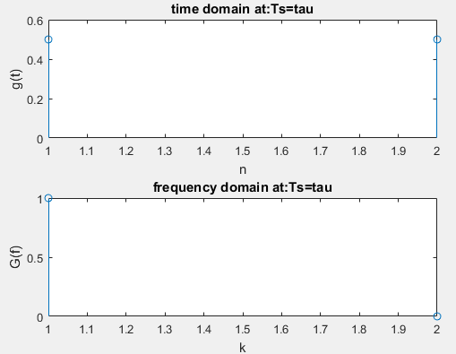

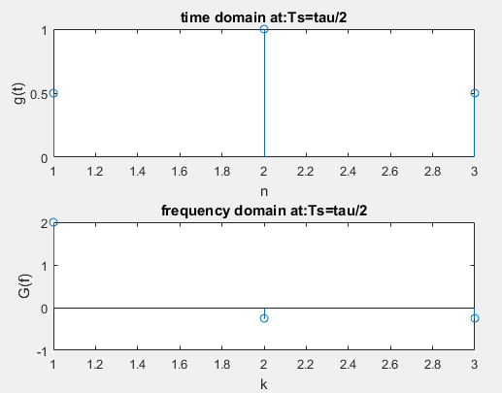

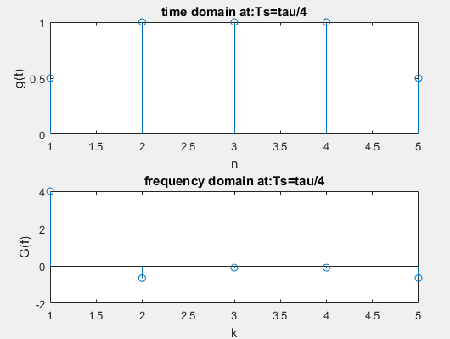

## Observation

By decrease the sample time we can see the effect more easily and understand the signal. If the value of the sample time is decreasing the more points come in time domain as time domain.

# 3

### Observation

I observe in frequency domain and time domain sampling if we increase the frequency and decrease the sample time the overall width of the periodicity is increase and take reverse effect if we decrease the frequency and increase sample time. if we across the limit of decreasing frequency (which is Nyquist) then crossover occur and cause aliasing.